5. Unpacking The Big Idea with Visual Language

a. Superhero
Family photos
When I grow up…. Artist, Teacher, Doctor, Paleontologist, Ballerina
Pageants
Princess
Gender stereotype…colors as boy or girl colors, specific boy roles and specific girl roles
Angry Birds
Sports
Pets
Where students are from…state, country, culture, region, nationality (flags and symbols)
Religion (symbols and religious icons)

b. Frida Kahlo, Self Portrait 1940
Andy Warhol, Self Portrait 1986
Lorna Simpson, Wigs 1994
Laurie Simmons, Blonde/Red Dress/Kitchen 1978
Maya Lin, Rock Field 1997
Kerry James Marshall, Our Town 1995
Paul Klee, Ghost of a Genius 1922
Georges Seurat, Sunday Afternoon on the Island of la Grande Jatte 1886
Norman Rockwell, Triple Self Portrait, 1960

c. Family photos are a good example of my big idea. As young children they will identify themselves with who the most important people are in their lives. Right or wrong children will often look at their parents as who they want to be when they grow up. Also, at this age they will be highly influenced by their parents and grandparents, even their siblings. Children look to their family members as a way to identify themselves based on race, religion and all other aspects development.
The painting, Sunday Afternoon on the Island of La Grande Jatte is a good example of my big idea along with the essential question: how is identity affected by our community? This painting offers a great deal of discussion question ideas and can give students and idea of how we can see ourselves through friends and family. This gives me a way to involve art technique and art history into the lessons as well. I would hope this artwork will help students use their imaginations to create their own artwork.
I think addressing gender stereotypes would be helpful when understanding how our identity makes us unique. Even if it’s not addressed word for word to my students as a teacher I need to remember not to put those stereotypes on my students. I want the art room to be a safe place where students are free to be themselves without judgment. I could definitely talk about stereotypes and help the students understand there is no reason for specific gender roles in society but we put them on ourselves.

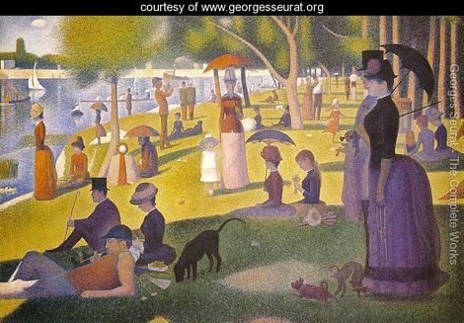
Sunday Afternoon on the Island of La Grande Jatte, Georges Suerat, 1886, oil on canvas

